|  |  |  |  |  |  |
| --- | --- | --- | --- | --- | --- |
| Variable Name | Test Type | Test Data | Purpose of Data | User’s Expected Result | Actual Result |
| choice[0] | string | wjw, y.1, 1 | To continue program | Clears the screen and continues the program. If wrong input is inputted exits the program. Otherwise returns 0 and exits the program. | Clears the screen and continues the program. If wrong input is inputted exits the program. Otherwise returns 0 and exits the program. |

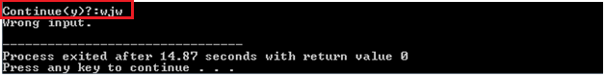

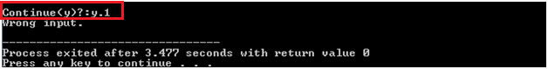

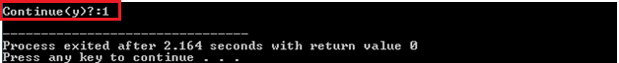

|  |  |  |  |  |  |
| --- | --- | --- | --- | --- | --- |
| Variable Name | Test Type | Test Data | Purpose of Data | User’s Expected Result | Actual Result |
| choice[0] | string | x, 0, a.2 | User choice | The user can enter a, b, c, d, e or f to utilize the inventory. Otherwise, exits the program. | The user can enter a, b, c, d, e or f to utilize the inventory. Otherwise, exits the program. |

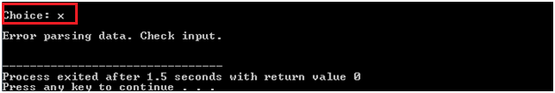

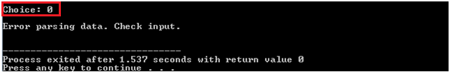

|  |  |  |  |  |  |
| --- | --- | --- | --- | --- | --- |
| Variable Name | Test Type | Test Data | Purpose of Data | User’s Expected Result | Actual Result |
| append.barcode  search.barcode | string | sdkjwlk, 120172, LGSI2991, MGSI1202.2 | To store product barcode | The product stores the barcode number or exits the program if wrong input is provided. | The product stores the barcode number or exits the program if wrong input is provided. |

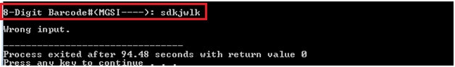

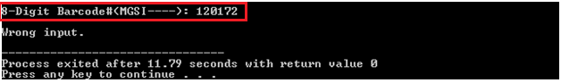

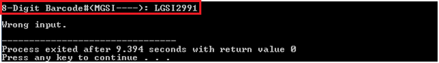

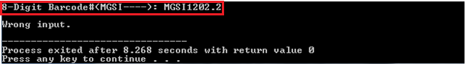

|  |  |  |  |  |  |
| --- | --- | --- | --- | --- | --- |
| Variable Name | Test Type | Test Data | Purpose of Data | User’s Expected Result | Actual Result |
| append.price | float | 0, -12929 | To store product price | The program stores the price information or exits the program if wrong input is provided. | The program stores the price information or exits the program if wrong input is provided. |

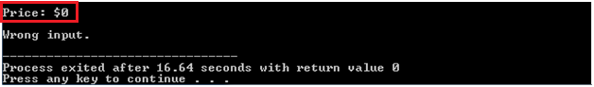

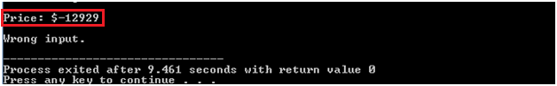

|  |  |  |  |  |  |
| --- | --- | --- | --- | --- | --- |
| Variable Name | Test Type | Test Data | Purpose of Data | User’s Expected Result | Actual Result |
| budget | float | sksk | To store budget value to calculate stocks | The program stores the budget price. If characters are inputted, exits the program. | The program stores the budget price. If characters are inputted, exits the program. |

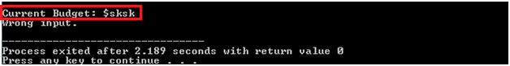

|  |  |  |  |  |  |
| --- | --- | --- | --- | --- | --- |
| Variable Name | Test Type | Test Data | Purpose of Data | User’s Expected Result | Actual Result |
| itemssold | integer | soeoe | To store item number to calculate total income | Stores the number of items. If number of items are 0 or characters, exits the program. | Stores the number of items. If number of items are 0 or characters, exits the program. |

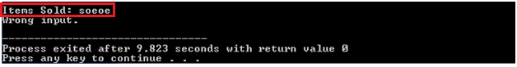

|  |  |  |  |  |  |
| --- | --- | --- | --- | --- | --- |
| Variable Name | Test Type | Test Data | Purpose of Data | User’s Expected Result | Actual Result |
| current_price | float | skksks, 0 | To store prices of items to calculate total income. | Stores the income values and displays the total income. If a character or 0 income is inputted, exits the program. | Stores the income values and displays the total income. If a character or 0 income is inputted, exits the program. |

